**ALL LEVELS**

**ONE-DIGIT NUMBER ADDITION**

**ADDITION WITHOUT REGROUPING**

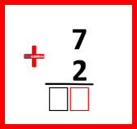**LEVEL 1.** Adding numbers 0 and 1 GO TO LEVEL 1

**LEVEL 2.** Adding numbers 0, 1 and 2 GO TO LEVEL 2

**LEVEL 3.** Adding numbers 0, 1, 2 and 3 GO TO LEVEL 3

**LEVEL 4.** Adding numbers 0, 1, 2, 3 and 4 GO TO LEVEL 4

**LEVEL 5.** REVIEW. Additions from levels 1 – 4 GO TO LEVEL 5

**LEVEL 6.** Adding numbers 0, 1, 2, 3, 4 and 5 GO TO LEVEL 6

**LEVEL 7.** Adding numbers 0, 1, 2, 3, 4, 5 and 6 GO TO LEVEL 7

**LEVEL 8.** Adding numbers 0, 1, 2, 3, 4, 5, 6 and 7 GO TO LEVEL 8

**LEVEL 9.** Adding numbers 0, 1, 2, 3, 4, 5, 6, 7 and 8 GO TO LEVEL 9

**LEVEL 10.** Adding numbers 0, 1, 2, 3, 4, 5, 6, 7, 8 and 9 GO TO LEVEL 10

**LEVEL 11.** REVIEW. Additions from levels 6 – 10 GO TO LEVEL 11

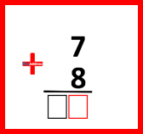**ADDITION WITH REGROUPING**

**LEVEL 12.** Adding numbers 0, 1, 2, 3, 4, 5, 6, 7, 8 and 9 GO TO LEVEL 12

**LEVEL 13.** REVIEW. Additions from levels 10 and 12 GO TO LEVEL 13

**TWO-DIGIT NUMBER ADDITION**

**TWO-DIGIT NUMBER + ONE-DIGIT NUMBER**

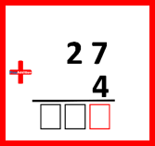**LEVEL 14.** Addition without Regrouping GO TO LEVEL 14

**LEVEL 15.** Addition with Regrouping in Ones GO TO LEVEL 15

**LEVEL 16.** Addition with Regrouping in Ones and Tens GO TO LEVEL 16

**LEVEL 17.** REVIEW. Additions from levels 14 – 16 GO TO LEVEL 17

**TWO-DIGIT NUMBER + TWO-DIGIT NUMBER**

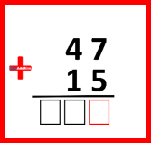**LEVEL 18.** Addition without Regrouping GO TO LEVEL 18

**LEVEL 19.** Addition with Regrouping in Ones GO TO LEVEL 19

**LEVEL 20.** Addition with Regrouping in Tens GO TO LEVEL 20

**LEVEL 21.** Addition with Regrouping in Ones and Tens GO TO LEVEL 2

**LEVEL 22.** REVIEW. Additions from levels 18 – 21 GO TO LEVEL 22

**THREE-DIGIT NUMBER ADDITION**

**THREE-DIGIT NUMBER + ONE-DIGIT NUMBER**

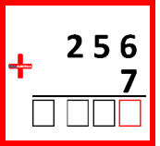**LEVEL 23.** Addition without Regrouping GO TO LEVEL 23

**LEVEL 24.** Addition with Regrouping in Ones GO TO LEVEL 24

**LEVEL 25.** REVIEW. Additions from levels 23 and 24 GO TO LEVEL 25

**THREE-DIGIT NUMBER + TWO-DIGIT NUMBER**

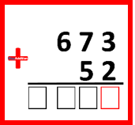**LEVEL 26.** Addition without Regrouping GO TO LEVEL 26

**LEVEL 27.** Addition with Regrouping in Ones GO TO LEVEL 27

**LEVEL 28.** Addition with Regrouping in Tens GO TO LEVEL 28

**LEVEL 29.** Addition with Regrouping in Ones and Tens GO TO LEVEL 29

**LEVEL 30.** Addition with Regrouping in Tens and Hundreds GO TO LEVEL 30

**LEVEL 31.** Addition with Regrouping in Units, Tens, and Hundreds GO TO LEVEL 31

**LEVEL 32.** REVIEW. Additions from levels 26 - 31 GO TO LEVEL 32

**THREE-DIGIT NUMBER + THREE -DIGIT NUMBER**

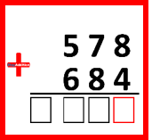**LEVEL 33.** Addition without Regrouping GO TO LEVEL 33

**LEVEL 34.** Addition with Regrouping in Ones GO TO LEVEL 34

**LEVEL 35.** Addition with Regrouping in Tens GO TO LEVEL 35

**LEVEL 36.** Addition with Regrouping in Ones and Tens GO TO LEVEL 36

**LEVEL 37.** Addition with Regrouping in Ones and Hundreds GO TO LEVEL 37

**LEVEL 38.** Addition with Regrouping in Tens and Hundreds GO TO LEVEL 38

**LEVEL 39.** Addition with Regrouping in Units, Tens, and Hundreds GO TO LEVEL 39

**LEVEL 40.** REVIEW. Additions from levels 33 – 39 GO TO LEVEL 40